Teens and makeup, a dangerous mix?
By Jenn Savedge , Forecast Earth Correspondent
Posted Mon Sep 29, 2008 2:23pm PDT
Related topics: Shopping, Safety, Beauty
More from Forecast Earth blog

62 votes
Buzz up!

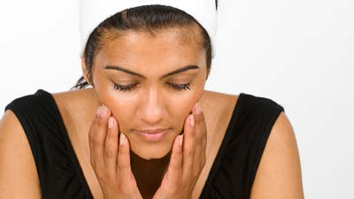
I had no sooner finished writing a post the other day about making homemade, eco-friendly face paints for kids when I found the results of a disturbing study recently released by the Environmental Working Group about toxins in cosmetics. Specifically, the study looked at the toxins that have found their way into the bodies of teenage girls who frequently use cosmetics.
According to the EWG study, 16 chemicals from 4 chemical families -- phthalates, triclosan, parabens, and musks -- were found in the blood and urine samples from 20 teen girls aged 14-19. These chemicals have been linked to serious health concerns such as cancer and hormone disruption. Two parabens in particular, methylparaben and propylparaben, were detected in every single girl tested. Parabens are a group of synthetic chemicals frequently used as preservatives in cosmetics.
The study also found that on average, teenage girls use more personal care products than adult women (17 products each day for teens compared to 12 for adults). So at a time when their bodies are rapidly changing and most susceptible to damage, many teens are unknowingly exposing themselves to extremely high levels of toxins from the products that are supposed to make them look beautiful.
Now, as a journalist with a scientific background, I can't overlook the fact that the sample size for the EWG's study was small at only 20 participants. And I understand that scientifically, the results are not significant.
But as a mom with two daughters, I also can't overlook the fact that this small study further verifies an already established environmental concern regarding the toxicity of ingredients in frequently used personal care products. And for me, it highlights the the very real fact that our children are exposed to an alarmingly number of synthetic chemicals each day, many of which have never been tested for safety in and of themselves and certainly not in combination with the thousands of other chemicals making their way into our children each day.
So what's the answer? Not allowing your teens to wear cosmetics? My daughters are at least 10 years away from the day when they turn in their "play" makeup for the real thing, but even I know that for teens who love their personal care products, an out-and-out ban would spell disaster.
A better idea is to talk to your teen about the nasty junk she's putting on her face (dare her to read the label!) and turn her on to some of the great brands currently available, like Miessence, Jane Iredale, Honeybee Gardens, and Ecco Bella, that are made without those dangerous ingredients. If she's got to wear makeup, at least you'll know that the stuff she's putting on the outside, won't hurt her on the inside.
Jenn Savedge's blog posts are provided by LifeWire, a part of The New York Times Company.

