Name Date
Fossil Writing

What happens When?
Place the following pictures in chronological order. Put pictures in order according to the letter in each box with number 1 happening first.
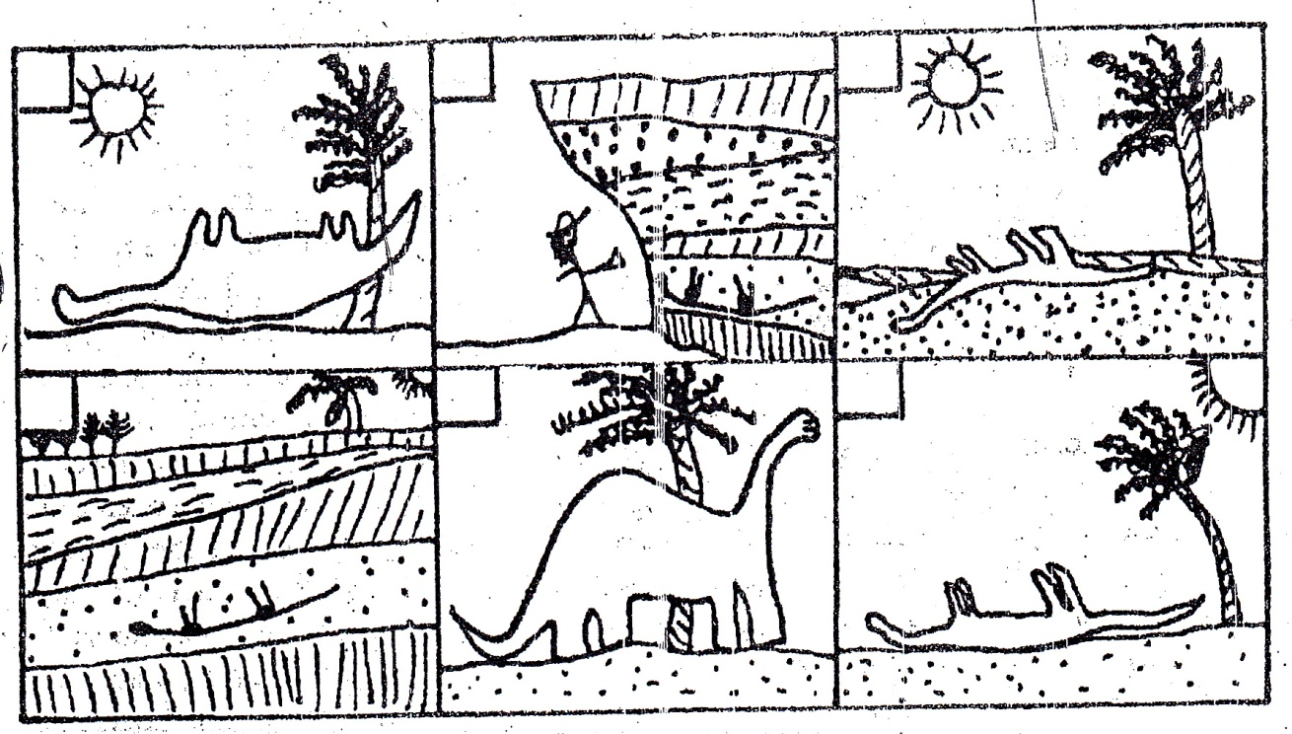
F
E
D
B
C
A

Using complete sentences, explain the correct order in which the dinosaur from above came to be a fossil. Once the dinosaur fossil was discovered it was considered an “index fossil”. Explain what an index fossil is and what it tells scientists about the rock layer in which it was found and the rock layers surrounding it. Make sure to use complete sentences for each frame.

