Forming a Fossil Writing Activity
Modified

Place the following pictures in the order that they happened. Put the pictures in order according to the letters in the box with the first thing that happened, then 2 in the next event, and so on…

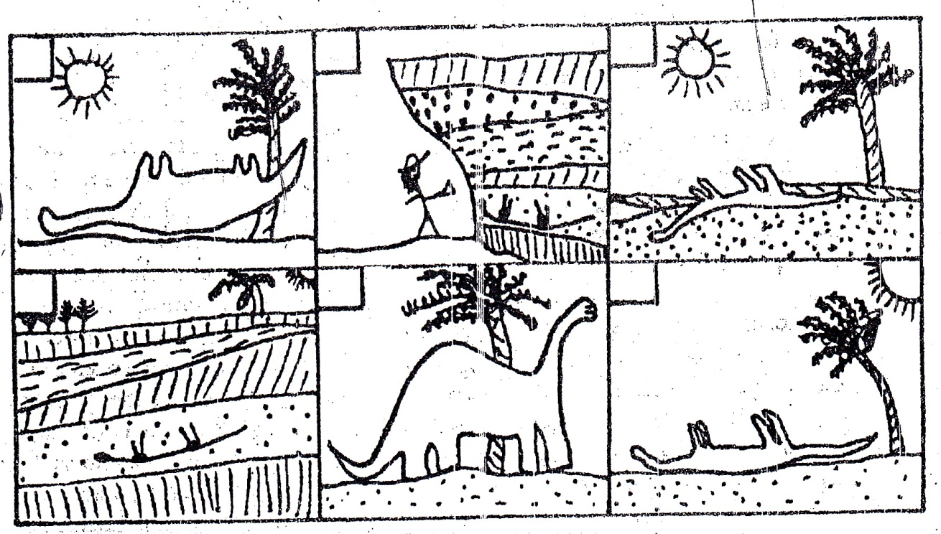
F
E
D
B
C
A

How did the dinosaur become a fossil?
Write a story about how the dinosaur became a fossil.
You need at least 1 sentence for each box. Use these words in your sentences.
Fossil rock layer sediment Pressure squeeze geologist Decay dinosaur cover Buried

- First, the dinosaur is alive.
- Next, the ___________________ dies.
- Third, the dinosaur is ___________ with _________________.
- Then, the sediment puts _____________________ on the dinosaur, ______________ the dinosaur to start the process.
- After the dinosaur is ____________, it begins to _______________________.
- Lastly, ____________ can use the _______________ to help identify how old the _____________ is.

What makes the dinosaur bones an “index fossil”? What can scientists learn about the rocks from looking at this dinosaur fossil? (Write this on the BACK)
An “index fossil” is made when

By looking at this dinosaur fossil, scientists can learn that rocks

