Forming a Fossil Writing Activity
Modified

Place the following pictures in the order that they happened. Put the pictures in order according to letter noting the first thing that happened, then the next event, and so on…
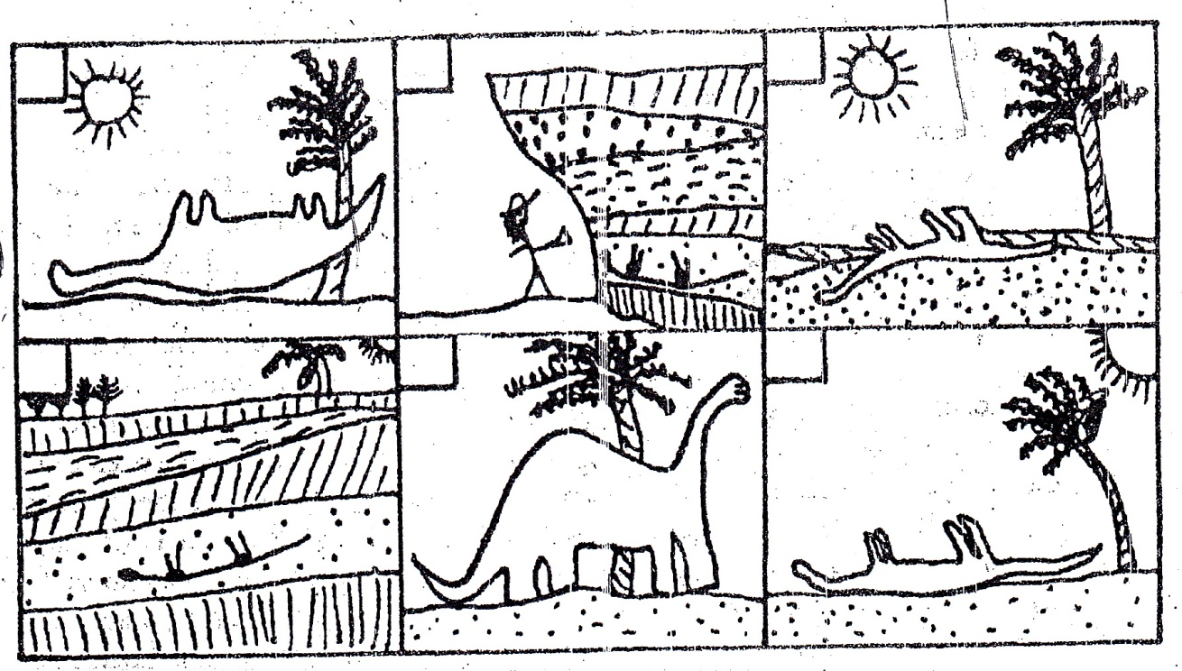
C
D
E
F
B
A

How did the dinosaur become a fossil?
Write a story to tell how the dinosaur became a fossil. You need at least 1 sentence for each box. Use these words in your sentences.
Fossil rock layer sediment Pressure squeeze geologist
Decay dinosaur cover

What makes the dinosaur bones an “index fossil”? What can scientists learn about the rocks from looking at this dinosaur fossil? (Write this on the BACK)

You will be putting all your information on a separate sheet of paper and posting it on scienceeagle.weebly site for your class period.

