Big Quakes Common in Caribbean: BIG PIC MAP
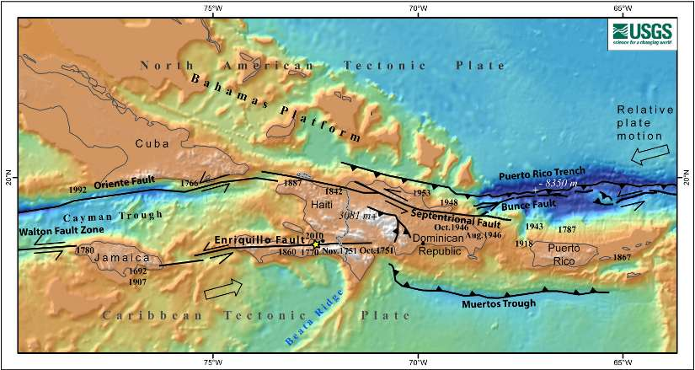
Tsunamis lashing Puerto Rico. Devastating earthquakes repeatedly rocking the Virgin Islands, Dominican Republic and Jamaica. These are the realities of the Caribbean's tectonic past, but until Tuesday's horrifying magnitude 7.0 temblor struck Haiti, few people knew of them.
The above map shows known earthquakes equivalent to or greater in magnitude than this week's disaster. The frequency is striking: there have been twenty such events over the past four centuries, including five in Haiti since 1751.
Because of their status as United States territories, Puerto Rico and the U.S. Virgin Islands have enjoyed the lion's share of scientific scrutiny. For instance, seismologists know that faults north of Puerto Rico hosted a magnitude 7.3 quake in 1918, a 7.8 in 1943, and a magnitude 8.0 in 1946. The 1946 quake spawned a tsunami that killed 1,800 people.
But for the rest of the region, geologists at the United States Geological Survey recently wrote:
Puerto Rico and the Virgin Islands are located at an active plate boundary between the North American plate and the northeast corner of the Caribbean plate. Plate movements there have caused large magnitude earthquakes and devastating tsunamis, but scientists have so far failed to explain the deformation of this complex region in a coherent and predictable picture, and this has hampered their ability to assess the seismic and tsunami hazards. It is as if we would try to assess earthquake hazards in California without knowing of the existence of the San Andreas Fault system and its rate of motion.
Countries in the Caribbean generally have resources that are too modest to support the kind of research needed to understand these faults, and so they remain a dangerous mystery to the millions of people living near them.
With the region alive with grinding tectonic plates, it is only a matter of time before the next large temblor hits. The only question is whether we will learn from the current disaster, and make sure that those in harm's way are better prepared for the inevitable.
Image: Uri ten Brink, USGS

